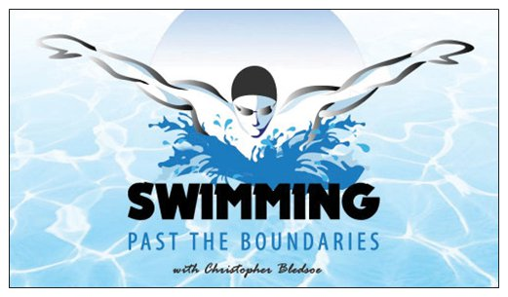  Open Lap Swim: Now Available! Visit our site for details  Group Lessons: 4 students $20 Per Week or $60 Per month  Semi Private Lessons: 2 Students $30 per student  Private Lessons: 1 student $60 per lesson  Large Group Lessons: 5 students or more $15 per student  Pool Parties: $200 per hour: DJ, Glow Sticks and Light Show included in price.  Swim Camps: $20 per week or $60 per month TOTAL FUN!  Aqua Yoga: $15 Per 45 min Class  Aqua Therapy: $15 Per 45 min Class  Student Name: ________________________________________________  Student Name # 2_____________________________________________  Student Name # 3_____________________________________________  Student Name # 4_____________________________________________  Parent/Company Name: _______________________________________  Address: ______________________________________________________  Cell Number: __________________________________________________  Emergency Contact: ___________________________________________  Emergency Contact Cell: _______________________________________  Class Enrollment: ______________________________________________  Day and Time Class Request: __________________________________  Credit Card Number: ___________________________________________  Exp Date: ________CVV______  Medical Concerns: _______________________________________________  ALL CHECKS MADE PAYABLE TO “SWIMMING PAST THE BOUNDARIES”  www.swimmingpastboundaries.com | SWIM CAMPS  AQUA THERAPY  GROUP LESSONS  PRIVATE LESSONS  SWIM AND PLAY  AQUA YOGA  SPECIAL NEEDS  POOL PARTIES  COMPETITIVE SWIM TRAINING  AQUA FITNESS!  Swimming Past the Boundaries  110 S Grand Ave  Poughkeepsie, NY 12603  swimmingpastboundaries.com  Corp Office: 845-625-4929

